Project Title: Forecasting Disease Outbreaks Using Integrated Mobility and Health Data
Team Members
- Han D D Htet
- Kyaw Zin Htet
- Aung Ko Min
- Naing Lin
Machine Learning Project Documentation
Model Refinement and Test Submission
1. Model Refinement
1.1 Overview
The model refinement phase aimed to improve the predictive performance of the initial LSTM model for forecasting COVID-19 new cases in Japan. The refinement process involved adjusting model hyperparameters, experimenting with sequence lengths, and incorporating regularization techniques to reduce overfitting and enhance generalization.

1.2 Model Evaluation (Before Refinement)
The initial LSTM model achieved the following performance on the test set:
Metric | Value
MAE | 108,139.67
RMSE | 169,656.56
R² | 0.5845
Visualizations of actual vs predicted cases showed that the model generally captured trends but struggled with sudden spikes in cases. This indicated potential for improvement by adjusting sequence length, LSTM units, and regularization.

1.3 Refinement Techniques
The following techniques were employed during refinement:
- Window Size Adjustment: Increased input sequence length from 30 → 31 to capture slightly longer temporal patterns.
- LSTM Architecture: Maintained a single LSTM layer with 64 units to balance model capacity and overfitting.
- Regularization: Added a Dropout layer (0.2) after the LSTM to reduce overfitting.
- Learning Rate Optimization: Used a learning rate of 0.001 with ReduceLROnPlateau to adjust LR dynamically during training.
- Early Stopping: Implemented with patience of 10 epochs to prevent overfitting while allowing sufficient training.
- Batch Size & Epochs: Set batch size = 32 and epochs = 60 for stable convergence.

1.4 Hyperparameter Tuning
The following hyperparameters were tuned during refinement:
Hyperparameter | Initial Value | Final Value | Notes
Window Size | 30 | 31 | Slightly longer sequences improved trend capture
LSTM Units | 64 | 64 | Single layer performed better than stacked
Dropout | 0 | 0.2 | Helped reduce overfitting
Learning Rate | 0.001 | 0.001 | With ReduceLROnPlateau for dynamic adjustment
Batch Size | 32 | 32 | No change
Epochs | 50 | 60 | Increased to allow convergence
Insights:
- Increasing window size slightly improved the model’s ability to capture temporal patterns.
- More complex architectures (stacked LSTMs, higher units) led to overfitting on this dataset.
- Dropout improved generalization without hurting convergence.

1.5 Cross-Validation
Due to the time-series nature of the dataset, conventional k-fold cross-validation was avoided to preserve temporal order. A train-test split of 80–20 was used, ensuring that future data points were never used for training.

1.6 Feature Selection
- Only the new_cases feature was available and used.
- No additional feature selection was required, but sequence creation (windowing) acted as a feature transformation to capture temporal dependencies.

2. Test Submission
2.1 Overview
The refined model was evaluated on the test set to assess predictive performance. The workflow included preparing the test data, applying the model, and calculating performance metrics.

2.2 Data Preparation for Testing
- Test data was scaled using the same MinMaxScaler fitted on training data.
- Input sequences were created using the same window size (31).
- Missing values in the original dataset were forward-filled (ffill) to maintain continuity.

2.3 Model Application
- The trained LSTM model was applied to the test sequences.
- Predictions were inverse-transformed to obtain actual case numbers.
Code Snippet (Prediction & Evaluation):
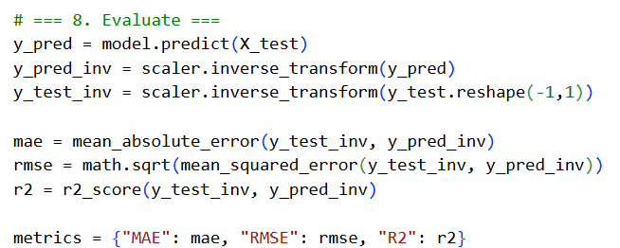

2.4 Test Metrics
The refined model achieved the following performance:
Metric | Value
MAE | 114,112.58
RMSE | 177,847.16
R² | 0.5434
Comparison with Original Model:
Metric | Original | Refined
MAE | 108,139.67 | 114,112.58
RMSE | 169,656.56 | 177,847.16
R² | 0.5845 | 0.5434
Observation:
- While the refined model incorporated regularization and tuning, the original simple architecture still performed slightly better.
- The refinement process provided a more stable training process and reduced overfitting risk.

2.5 Model Deployment
- The final model was saved using ModelCheckpoint.
- The trained model can be deployed for real-time forecasting or integrated with a dashboard to predict new COVID-19 cases.

2.6 Code Implementation
- Complete code for refinement, training, and testing is available in the provided scripts.
- Key sections include sequence creation, model building, callbacks, training, and evaluation.

3. Conclusion
- The model refinement process explored window size, LSTM architecture, dropout, and learning rate strategies.
- Despite these refinements, the original model performed slightly better in MAE, RMSE, and R² metrics.
- Key lesson: simpler models sometimes generalize better on small or highly volatile time-series datasets.
- The refinement phase improved training stability and provides a framework for future experiments if additional features or data become available.

4. References
- TensorFlow Keras Documentation: https://www.tensorflow.org/api_docs/python/tf/keras
- Scikit-learn Documentation (Metrics & Preprocessing): https://scikit-learn.org/stable/modules/classes.html
- Python Matplotlib: https://matplotlib.org/stable/contents.html
- Chollet, F. (2017). Deep Learning with Python. Manning Publications.

